**Experiment-6 Implementing Dynamic Routing using CLI**

ECP316 (Communication Networks)

**Aim:** Understanding and implementing dynamic routing using CLI for simulating package transfer between different networks.

**Tools Used:** Cisco Packet Tracer

**Theory:**

Dynamic routing is an automated network routing technique where routers exchange routing information and adjust paths dynamically based on network changes. Using the Command Line Interface (CLI), administrators configure routing protocols like **RIP, OSPF, or EIGRP**, enabling adaptive and efficient data transfer across networks. It is ideal for large, scalable networks as it reduces manual updates.

### **Difference Between CLI and Normal Mode**

* **CLI (Command Line Interface):** A text-based interface where commands are manually entered for configuring dynamic routing protocols, making real-time network adjustments, and troubleshooting.
* **Normal Mode (GUI - Graphical User Interface):** A visual interface for configuration, often with drag-and-drop features, making setup easier but offering less flexibility and control than CLI.

**CLI Commands:**

* **Press Enter** ; to start CLI
* **Router>enable** ; to enable the Router
* **Router#configure terminal** ; to configure
* **Route(config)#int <port>** ; selecting Port
* **Router(config-if)#ip add <ip> <mask>** ; to add ip address to port
* **Router(config-if)#no shut** ; to turn on the router port
* **Router(config-if)#exit** ; exit to normal configure
* **Router(config)#router rip** ; setting router to RIP which is dynamic routing
* **Router(config)#network <ip>** ; set all possible IPs

**CLI Commands:**

**Router 1:**

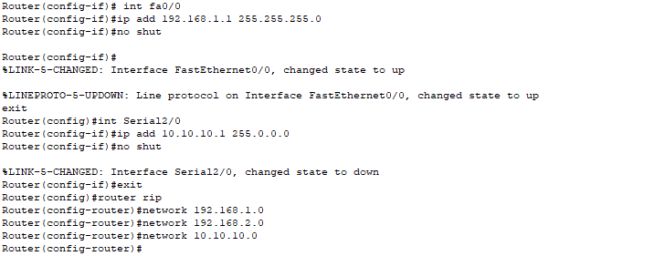

**Router 2:**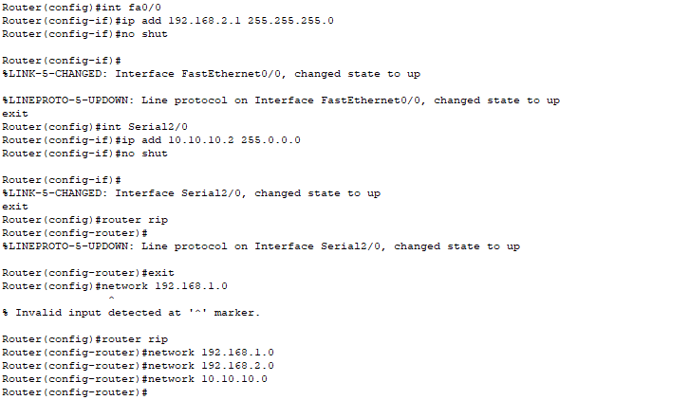

**Procedure:**

1. Open Cisco Packet Tracer application on computer.
2. Use PCs and give them IP addresses to the PCs and then configure using CLI Commands.
3. Use PT Switch and Router only as they’re already defined according to our use.
4. Use RJ45 Cables to connect the PCs and switches as according to the topology diagram. We can check the connections using ping in the command prompt of each PC.
5. Try sending mail from one PC to another and start simulation and observe.
6. Try Sending on different paths like 1st router sub-PC to 2nd router sub-PC etc..

**Connections:**

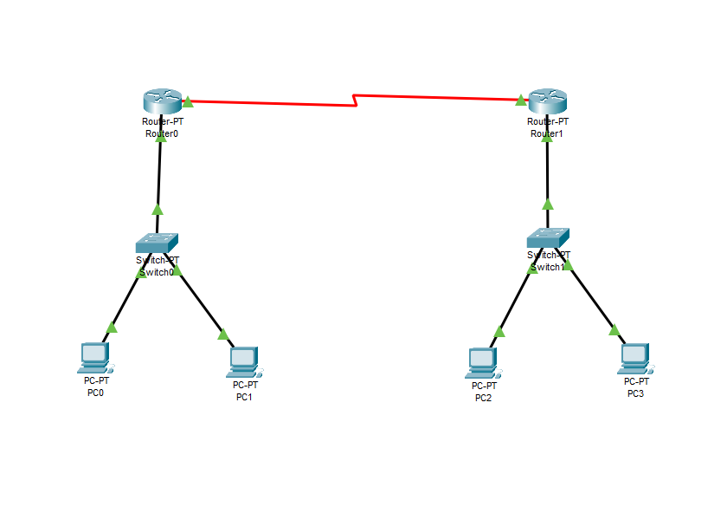

**Testing on Routes (Simulation):**

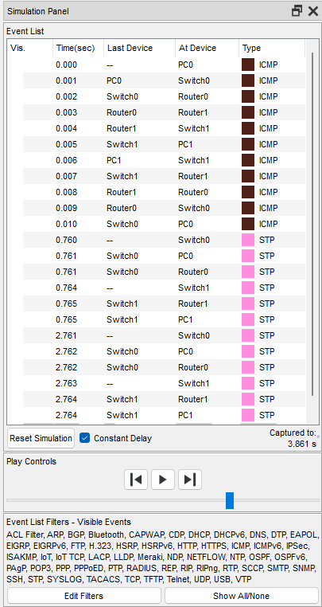

**Success:**

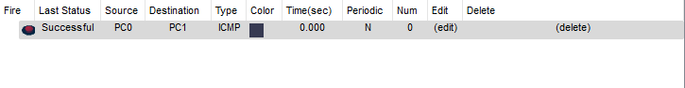

**Result:**

In this experiment, we implemented **dynamic routing using CLI** to connect three routers and their PCs, ensuring end-to-end communication. Unlike GUI-based setups, CLI allowed precise manual route configurations, ensuring controlled packet transfer.

**Conclusion:**

1. Successfully implemented dynamic routing using CLI to enable seamless communication between routers and connected PCs.
2. Routing protocols (RIP, OSPF, EIGRP) allowed automatic route learning and updates, reducing manual configuration.
3. CLI-based configuration provided precise control over routing tables and network settings.
4. Improved scalability and adaptability, making it suitable for large and complex networks.
5. Faster convergence in case of topology changes compared to static routing.
6. Reduced administrative overhead, as routers dynamically adjust paths without manual intervention.
7. Demonstrated the efficiency of dynamic routing in maintaining optimal network performance in real-time scenarios.